Fertilizer "Agrolinija-S" effect on corn yield and its quality
REPORT 2019
1. Testers and location:
Alexander Stulginsky University
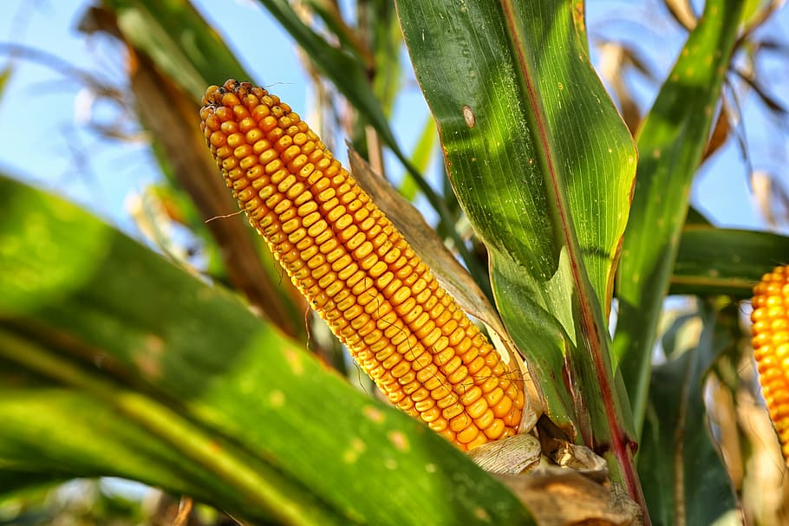
2. Fertilizer: Organic fertilizer-biostimulant - Agrolinija-S
3. Culture under study: Corn, hybrid Talisman

4. Soil

4.1. type: loam;

4.2. mechanical composition: loose sand:

4.3. humus content: 1.58%;

4.4. Acidity: pH 5.40;

4.5. availability of macro- and microelements: P2O5 - 410 mg / kg, K2O - 180 mg / kg. The content of mobile forms of copper (1.0 M HCl) - 2.0 mg / kg, zinc (Zn) (1.0 M HCl) - 3.3 mg / kg, manganese exchange (1.0 M KCl) - 2.6 mg / kg, water-soluble boron - 0.65 mg / kg.

5. Agrotechnical test conditions:

5.1. precursor of the plant on which the tests are carried out: spring barley;

5.2. tillage: plowing to a depth of 25 cm (17.10.2018), tillage to a depth of 12 cm (10.04.2019);

5.3. Application of fertilizers: mineral fertilizers (long-term): basic - phosphorus - 60 kg / ha, potassium - 150 kg / ha (2018-10-17), nitrogen - 140 kg / ha (2019-04-10);

organics: cattle manure 60 t / ha (2018-10-17);

5.4. Sowing date: 2019-04-12;

5.5. sowing rate: 100 thousand/ μl. seeds / ha;

5.6. the name and time of the activity of crop care (planting): treatment with the herbicide Meister Power - 1.5 l / ha (2016-10-05);

6. Agrometeorological test conditions (general characteristic):
Precipitation in mm during the growing season: long-term average - 311 mm, in the test year - 232 mm. Air temperature during the growing season: the average long-term value of the sum of active temperatures above 10 ° C is 2134 ° C, in the test year - 2432 ° C.
In general, meteorological conditions during the corn growing season were arid, since during that period the air temperature was above the long-term average values, and the amount of precipitation was below the long-term average values.

7. Type of study: field.

8. Size (m2) and plot allocation: total plot area 56 m2, accounting area of the plot 37.8 m2, distribution of the plot at random;

number of repetitions of the experiment: 4 times.

9. Test scheme:

9.1. plot variant: N₁₄₀Р₆₀К₁₅₀ +60 t / ha of cattle manure –Background;

9.2. Background + test fertilizer: Agroline-S - norm -2.0 l / ha.

10. Duration of fertilizer application: vegetation of plants

Dates: 06/04/2019, 06/06/2019

11. Fertilizer spraying method: spraying through the leaves

12. During the application of fertilizers in the phase of plant development: 1 - 5-6 leaves, 2 - 8-10 leaves.

13. Information on the compatibility of tested fertilizers with other fertilizers, plant protection products and other substances: not studied.

14. Identified side effects: not observed.

15. Information on the effect of fertilisers on biochemical product quality indicators:

The use of fertilizers Agrolinia-S, in comparison with the background variant, significantly increased the nitrogen content in corn grains (0.12%) and, accordingly, green and digestible proteins. The levels of phosphorus (0.03-0.04%) and Potassium (0.03%) also increased. (Table 1)

Table 1. The effect of "Agrolinija-S" fertilizers on the quality indicators of corn grains
Options | Crude protein,% | digestible proteins,% | N,% in dry mass | P2O5,% in dry mass | K2O,% in dry mass
N140P60K150 + 60 t / ha cattle manure  -Background | 7,91 | 6,41 | 1,33 | 0,28 | 0,4
Background + Agrolinija-S | 8,63 | 7,00 | 1,45 | 0,32 | 0,43

16. Assessment of the economic efficiency of fertilizers (with the indication of the minimum significant difference):

In the course of research, it was found that spraying through the leaves, fertilizer Agrolinia-S, increased the yield of corn grains by 1.7 t / ha compared to the background version (Table 2).

Table 2. The effect of Agrolinija-S fertilizers on the yield of corn grains.
Options | Yield t /ha, | Additive in comparison with the background, t/ha | Additive in comparison with the background, %
N140P60K150 + 60 t / ha cattle manure  -Background | 16,8
Background + Agrolinija-S | 18,5 | 1,700 | 10,2

When carrying out two sprayings with Agrolinia-S fertilizers, there was a tendency to increase the mass of one cob, grain from one cob , as well as 1000 grains (Table 3).

Table 3. The effect of Agrolinija-S fertilizers on the structure of corn crops
Options | mass, g
 | single cob, g | grain from the cob, g | 1000 Grain, g
N140P60K150 + 60 t / ha cattle manure  -Background | 226 | 159 | 305,9
Background + Agrolinija-S | 245 | 173 | 315,3

17. Conclusion:

Fertilizer "Agrolinia-S" additional application when fertilizing through the leaves to background fertilizing for corn crops, at the stages of 5-6 and 8-10 leaves, increased the grain yield by -1.7 t / ha. or 10.2%.

